ROOM

A Room of One's Own By Heather Alexander



**A Dramatic Interpretation of Virginia Woolf's iconic lectures**

**Background**

*A Room of One's Own* is an extended essay by Virginia Woolf based on a series of lectures she delivered at Newnham and Girton women's Colleges in Cambridge in 1928. A Room Of One's Own is an iconic feminist text championing the need for both a literal and figural space (Room) and financial independence for women writers within a literary tradition dominated by patriarchy.

**The Play**

Adapted and written by **Heather Alexander**

Directed by **Dominique Gerrard**

SOLO performance. Duration: 60 mins or 70 mins version with optional interval

Heather Alexander's unique dramatic interpretation of Virginia Woolf's A Room Of One's Own explores Woolf's fundamental ideas about gender, creativity and thwarted opportunity. The play explores Woolf's ideas in a bold and provocative production where we experience the narrator moving seamlessly between her study, lecture room, the British Museum and Oxbridge locations as she forms her ideas from her stream-of-consciousness musings. The text remains as relevant and important today as it invites the audience to reflect upon what and how much has changed?

All the famous passages from the essay are here: the realisation that poverty is a serious bar to women writing (still widely relevant today), the story of Shakespeare's sister, and the realisation that in fiction women must exist in relation to the world and each other, and not just as foils for men. That's the Bechdel Test, many years early.

"This is a measured, intelligent and watchable performance, bringing to life the qualities and thought processes of a very clever and well-educated woman ahead of her time.

A beautiful portrayal by an accomplished actor at the top of her game."

**Suzanne Hawkes. British Theatre Guide 2022**

**Watch the trailer here**: ROOM: <https://www.youtube.com/watch?v=38ZuYF2HVVA>

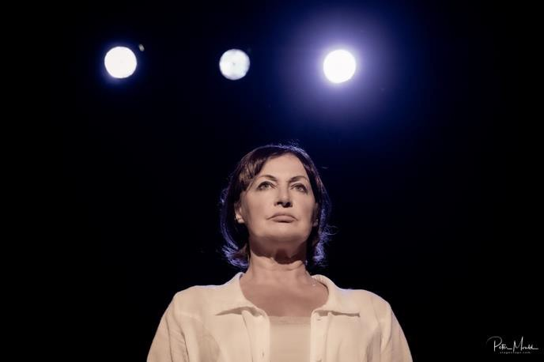

**The Actor**

**Heather Alexander** is an award winning actress (Best Female actor for ROOM – Buxton Fringe 2023) writer, director and producer with a long list of West End, stage, TV and film credits. Recently she has been performing ROOM, HAVISHAM and SHIRLEY VALENTINE to packed houses. Heather is also the founder and driving force behind the Hastings Fringe and Theatre Festivals.



**The Director**

**Dominique Gerrard** is a dramaturg and director working largely with writers on developing new plays. Recent credits include award winning production Quintessence (Emily Carding), SOE & A Necessary Woman (both for Clair Obscur Theatre) and Heather's previous work Room (Emul8). She runs Hastings Meisner and Vital Theatre.

**The Company**

**EMUL8 Theatre** seeks to explore the human condition through theatre that is ambitious and experimental but always accessible. We seek to expose, stimulate and challenge whilst never forgetting to entertain and avoid pretension, boredom and elitism. We seek to open a dialogue by exploring the space between laughter and pain; truth and fiction; fact and fantasy. We are completely inclusive and welcome creative collaboration with all mediums.

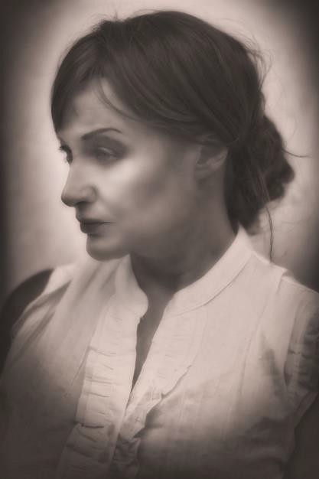

**The Reviews**

**AWARD**

**Best Female Actor – Buxton Fringe 2023**

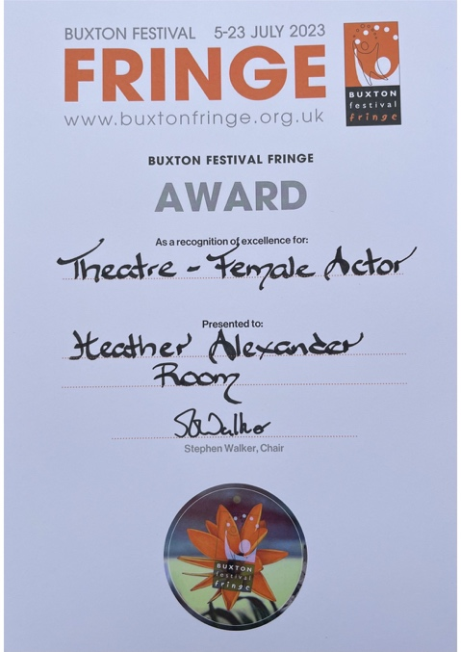

**Outstanding, Fringe Review**

Alexander draws Woolf's own threads necessarily tighter than even Woolf can. She has less time.

**This is an exquisite performance**, with equally exquisite use of props, a surprising amount of which are used to effect and point throughout. And there's a few shocks Woolf might not have contemplated.

**As a condensation and enactment of Woolf's seminal text this can't be improved on. The outstanding one-person show I've seen this Fringe.**

**Simon Jenner, 2022**

**4 Star, North West End UK**

Room- A Room of One's Own, written and performed by Heather Alexander, is a refined, intimate, and literary pleasure. A room for the soul, where one can meditate, reflect on contemporary reality, be enchanted by the beauty of prosody, and let oneself go with hope, not only in the future but also in an illustrious past that still lives within us.

A play that hits the nail on the head…written and performed by Heather

Alexander, is a **refined, intimate, and literary pleasure**.

**Anna Chiari (PHD Virginia Woolf), 2022**

**4 Star, British Theatre Guide**

**A beautiful portrayal** by an accomplished actor at the top of her game.

**Suzanne Hawkes, 2022**

**Highly Recommended, Fringe Review, 2022**

**Alexander's fine performance is searing and visceral**. This is a poised and provocative evening… It is a performance full of bravado and rich ideas that leaves the modern audience with much to reflect upon.

**Nicholas Collett, Fringe Review, 2022**

**5 Star, Buxton Fringe 2023. Winner Best Female Actor**

‘Alexander’s Woolf is a fully rounded presence onstage, intellectual, patrician, but also questioning, yearning, looking for answers. She conveys her frustrations at the limitations society places on her (in the women’s college she attends, the facilities are so much less than those of her male counterparts), and explores with feeling the idea of what it would have been like if Shakespeare had had a sister, with the same gifts as him, but none of the advantages of being male. She also posits a situation where two female scientists ‘like’ each other – she entreats us not to be shocked by such a suggestion – and there’s something beautiful but also sad in this scenario and the impossibility of it.

Heather Alexander, under the direction of Dominique Gerrard, makes Woolf a living, breathing character in her own right. It is a performance of subtlety and skill, never histrionic or over-dramatic, entirely believable. And through subtle visual clues, we are reminded this is not just a period piece. Virginia is first depicted looking every inch the 1920s feminist (high wasted trousers, braces – the detail of the costume is just right), but as the play progresses, the braces come off, the shirt is untucked, and she now resembles a modern woman, reminding us that while it might be easy to think that the world has changed since Woolf’s time, for many women, economic and societal pressures mean that the opportunities she calls for are still a long way off.’

**Robbie Carnegie 2023 (BUXTON FRINGE)**

**4 Star, Broadway Baby**

**Heather Alexander lit up the stage** as she portrayed one of the most fearless female writers in history.'

**Sascha Cooper, 2022**

**4 Star, Review Hub**

Alexander, as Room's writer, delivers a linguistic treat. The language is a joy to hear. As a performer, **Alexander is a delight to watch**. Her assured performance is pitch perfect, and her nuanced vocal delivery brings the rich language to life.'

**Sonny Waheed, 2022**

**4 Star, Wee Review**

This is a wonderful theatrical representation of a timeless essay.

**Stephen Walker, 2022**

**5/5 Marie Sibald**

'Very convincing and beautifully played…masterfully brought to the stage. I did enjoy the actors' convincing and captivating acting. **A play that stays in your memory** for a long time.'

**4/5 Fringe Biscuit**

'Refreshingly unsentimental, passionate & utterly absorbing, [@HAlexTheatre](https://twitter.com/HAlexTheatre) revels in the complexities & contradictions of Virginia Woolf. Feminism, class & artistic freedom are debated in this brilliantly detailed portrait of a formidable intellect.

**Chris Neville-Smith**

Heather Alexander has invented a new genre and format… performs as Virginia Woolf, with **the passion and conviction the real Virginia Woolf would have had**.

**Carly Fisher**

Alexander beautifully portrays Woolf…

**4 Star, Broadway Baby**

**Heather Alexander lit up the stage** as she portrayed one of the most fearless female writers in history.'

**Sascha Cooper, 2022**

**5 Star, Review Hub**

Alexander, as Room's writer, delivers a linguistic treat. The language is a joy to hear. As a performer, **Alexander is a delight to watch**. Her assured performance is pitch perfect, and her nuanced vocal delivery brings the rich language to life.'

**Sonny Waheed, 2022**

**4 Star, Wee Review**

This is a wonderful theatrical representation of a timeless essay.

**Stephen Walker, 2022**

**5/5 Marie Sibald**

'Very convincing and beautifully played…masterfully brought to the stage. I did enjoy the actors' convincing and captivating acting. **A play that stays in your memory** for a long time.'

**4/5 Fringe Biscuit**

'Refreshingly unsentimental, passionate & utterly absorbing, [@HAlexTheatre](https://twitter.com/HAlexTheatre) revels in the complexities & contradictions of Virginia Woolf. Feminism, class & artistic freedom are debated in this brilliantly detailed portrait of a formidable intellect.

**Chris Neville-Smith**

Heather Alexander has invented a new genre and format… performs as Virginia Woolf, with **the passion and conviction the real Virginia Woolf would have had**.

**Carly Fisher**

Alexander beautifully portrays Woolf…

* 5 STAR ⭐ ⭐ ⭐ ⭐ ⭐ REVIEW HUB: <https://www.thereviewshub.com/room-the-space-london/>
* OUTSTANDING, FRINGE REVIEW <http://fringereview.co.uk/review/brighton-fringe/2022/room/?fbclid=IwAR2Wyq9VySOE4eatJmRyLv4EK_xAGucIQ1Xg6YDjHZ5QqNjH7DREr69eQ0o>
* HIGHLY RECOMMENDED, FRINGE REVIEW: [http://fringereview.co.uk/review/hastings-fringe/2022/a-room-of-ones-own/](http://fringereview.co.uk/review/hastings-fringe/2022/a-room-of-ones-own/?fbclid=IwAR2oAKRLvxi5drXKIXnckSo71HyXtf43D1bUa5utjZ-VbLCyWrxdpppTHLI)
* 5 STAR ⭐ ⭐ ⭐ ⭐ ⭐ REVIEW – The Face (Jessica Morgan, Deputy Editor)
* 4 STAR ⭐ ⭐ ⭐ ⭐ Broadway Baby <https://broadwaybaby.com/shows/room-based-on-a-room-of-ones-own-by-virginia-woolf/759103>
* 4 STAR ⭐ ⭐ ⭐ ⭐ THE WEE REVIEW – Stephen Walker <https://theweereview.com/review/room-a-room-of-ones-own>

**Costings**

Emul8 Theatre offer shows on a fixed-cost basis or as a split. There are discounts for multiple shows.



**Publicity Material**

**100-word publicity copy**

It is 1929. An androgynous figure cuts a haunting shape in the shadows of Oxbridge. Scorned, ordered off the path; then refused entry to the library. Why? Woolf demands answers.

Woolf prowls the streets of London at dusk. A thousand thoughts consume her. Who can measure the violence of the poet's heart when tangled in a woman's body? What if Shakespeare had an equally gifted sister?

Woolf unflinchingly interrogates the crushing injustice she encounters. Witty. Relevant. Provocative. Woolf slices through notions of gender disparity with an incisive mix of integrity and visceral charm. Be afraid of Virginia Woolf.

**60-word publicity copy**

It is 1929. An androgynous figure haunts the shadows of Oxbridge. Scorned, ordered off the path; then refused entry to the library. Why? Woolf demands answers.

Woolf prowls the streets of London at dusk. A thousand thoughts consume her.

Faced with blatant injustice and inequality, Woolf slices through notions of gender disparity with a biting mix of integrity and visceral charm.

**30-word publicity copy**

Oxbridge. 1929. Faced with blatant injustice and inequality, Woolf slices through notions of gender disparity with a biting mix of integrity and visceral charm.

**Show Images by Peter Mould**

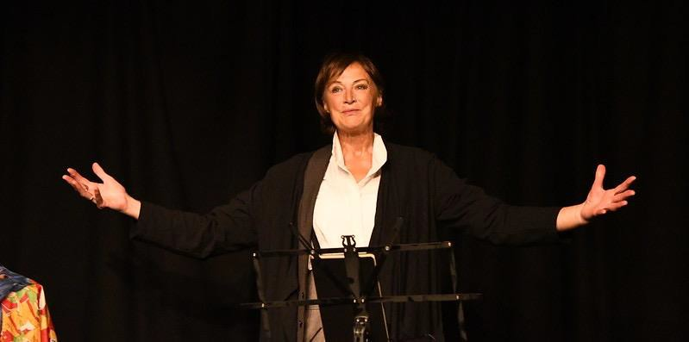

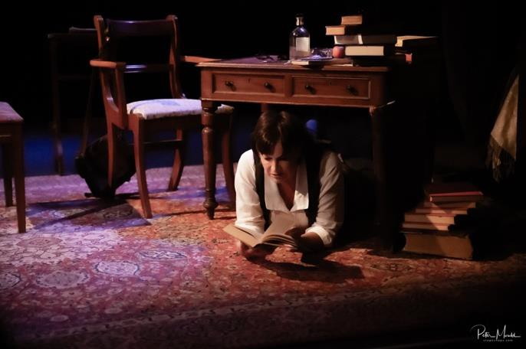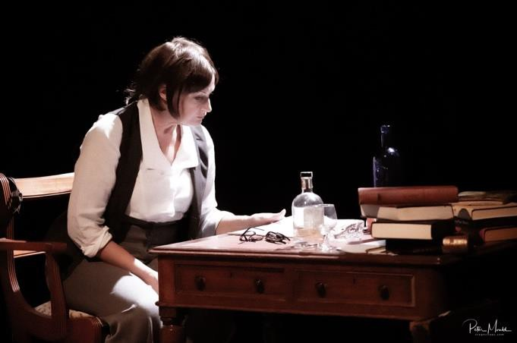

**Tour Posters**

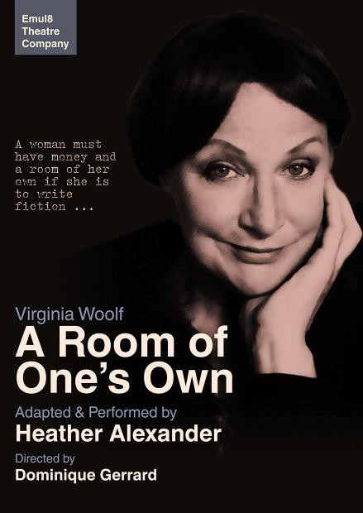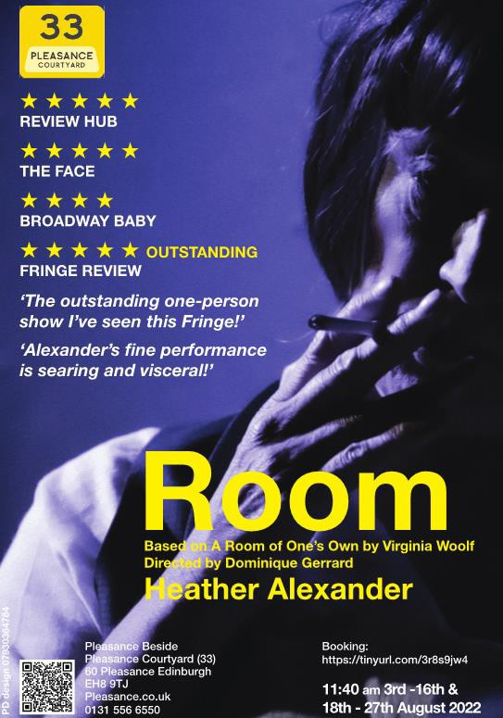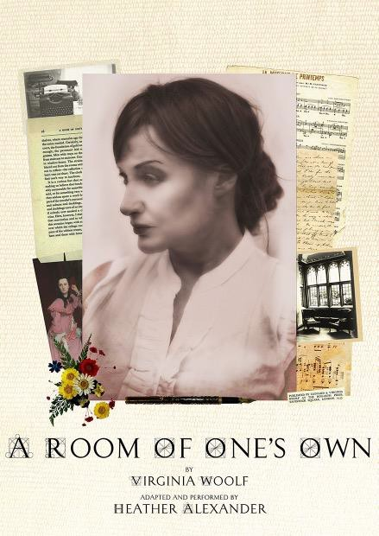

**Technical Information Traditional Theatre**

* Get in: 2/3 hours
* Get out 30 minutes

**Rural Touring**

* Get in: 1/2 hours
* Get out 30 minutes

**Sound**

Audio files and Cues/music are on Q-Lab We can provide USB and MacBook

For Rural Touring a portable light and sound system is available.

**Lighting**

Basic warm interior wash with, ideally, 3 specials.

For Rural Touring a portable light and sound system is available.

**Age Suitability: 12 +**

This is a guideline. The show does not contain nudity, profanity or offensive content.

**Duration:**

Solo performer

60 mins festival version

70 mins (with optional interval version)

Either can be offered with workshop. See RURAL TOURING

**Venues:** By varying the staging, Room can be adapted for most venues including libraries, festivals, galleries, village halls as well as traditional theatre etc.

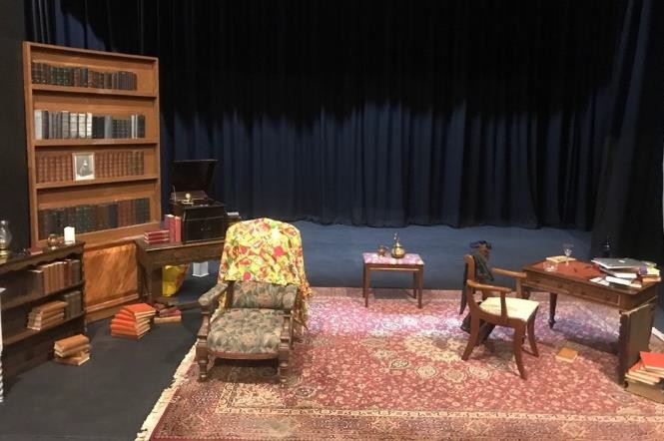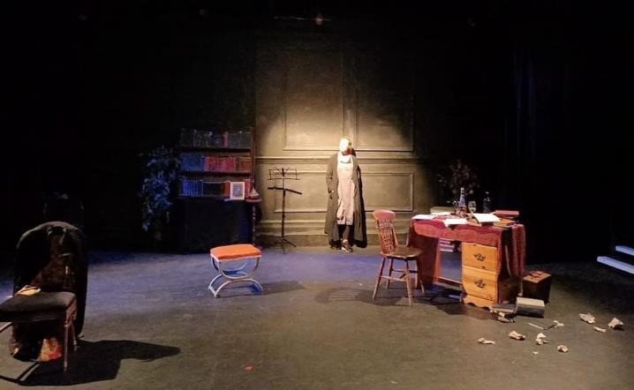

**RURAL TOURING**

Why ROOM is suitable for Rural Touring

Room is an **accessible** and unique dramatic interpretation of Virginia Woolf's A Room Of One's Own. We follow Woolf as she explores her thought processes about gender and creativity. We experience the narrator moving between her study, lecture room, the British Museum and Oxbridge locations as she forms her ideas. The text remains as relevant and important today as it invites the audience to reflect upon what and how much has changed?

All the famous passages from the essay are here: the realisation that poverty is a serious bar to women writing, the story of Shakespeare's sister, and the realisation that in writing fiction, women must find their own voice and place; not just exist as foils for men. That's the Bechdel Test, many years early.

This show seeks to inspire and empower a new audience and will appeal both to those familiar with Woolf and those new to her work. In taking the audience on a journey through her ‘stream of consciousness’ thought processes, we aim to create an atmosphere of enquiry where ‘anything is possible’ and encourage confidence and a recognition that creativity, writing and self-expression are for everyone to participate in; not just an educated ‘elite’. A short workshop can be included with the show which provides some simple and fun techniques that will encourage participants to explore their own ideas and try out some ‘stream of consciousness’ writing of their own. We aim to encourage a relaxed, creative atmosphere, within a safe space, that will facilitate the opportunity for participants to explore and express their ideas in a supportive, non-competitive environment. We strive to cultivate a new (renewed) interest in the possibilities of self-expression through journaling, expressive writing thus empowering the individual to explore their thoughts and feelings and thus fostering well-being and creative satisfaction.

**Promoting ROOM**

The show (and workshop) are unique, informative, educational and of contemporary relevance as well as of historical, literary relevance and interest.

Local promoters will be able to market the show (and workshop) to a wide-ranging potential audience appealing to those with a literary interest (and background) as well as those who may be new to Woolf's ideas and style.

Audience members typically remark and post on social media that the show inspires a new (or renewed) interest in Woolf's work. The audience are encouraged to recognise how reading , writing and creative expression can lead to feelings of empowerment and well-being.

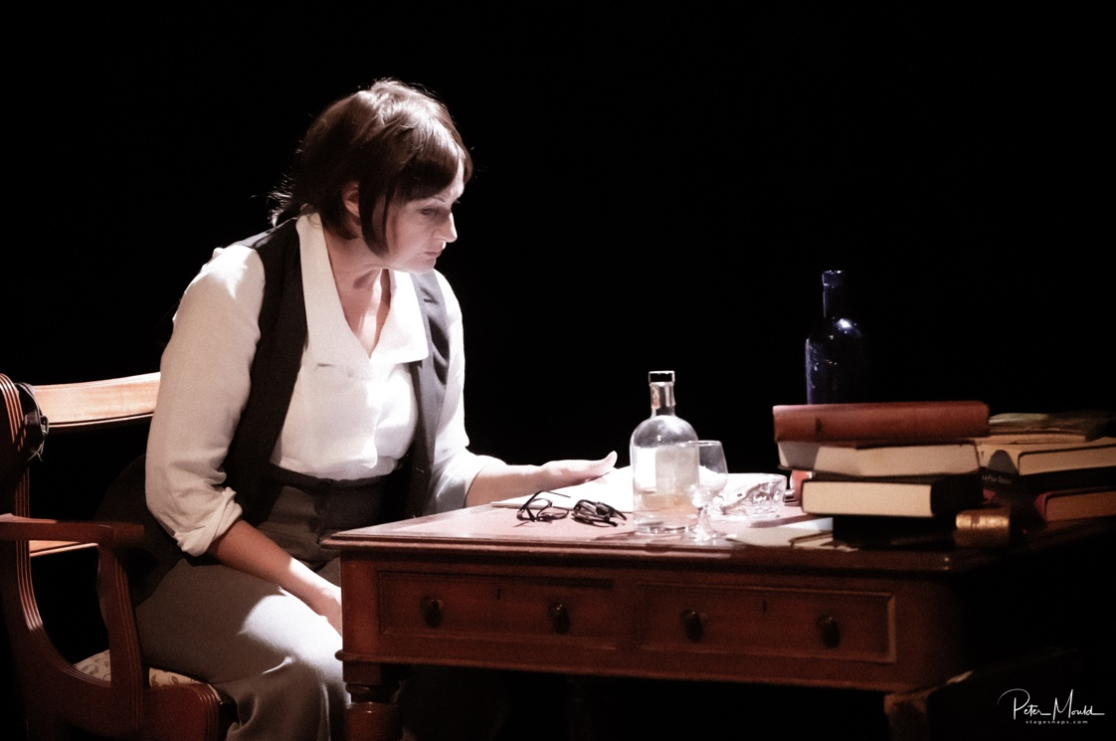

**PROMOTIONAL COPY**

**200 words**

Virginia Woolf lives! Why was Woolf refused entry to the library and pushed off the grass at Oxbridge? Who was Shakespeare’s Sister? Why is Woolf still a featuring in movies and why are bookshops still stocking and selling out of so many of her works? Find answers and discover why she is still taught in schools and universities today. Join us in the ROOM and see for yourself why her ideas are still so relevant today. Be part of the inspirational journey behind Woolf’s iconic lectures - A ROOM OF ONE’S OWN – one woman’s vision ahead of her time.

Award winning actress, Heather Alexander (Best female actor, Buxton Fringe 2023) shares Virginia Woolf’s ideas in a powerful new dramatic interpretation of A Room Of One's Own. The audience are invited into Woolf’s study and then follow her as she moves between lecture hall, the British Museum and Oxbridge. We share Woolf’s insights, her frustrations and her biting humour as she reflects on the many barriers that women have faced and how courageously female writers have fought to be recognised. A powerful exploration of an extraordinary woman.

**Contact Details**

**Email:**

emul8theatre@gmail.com

**Mobile:** 07970 820372

**Website:** [**http://www.heatheralexandershows.co.uk/**](http://www.heatheralexandershows.co.uk/)

**Instagram:** heatheralexandertheatre

**FB:** heather.alexander.1485 Roomvirginiawoolf

**Twitter**: @HAlexTheatre

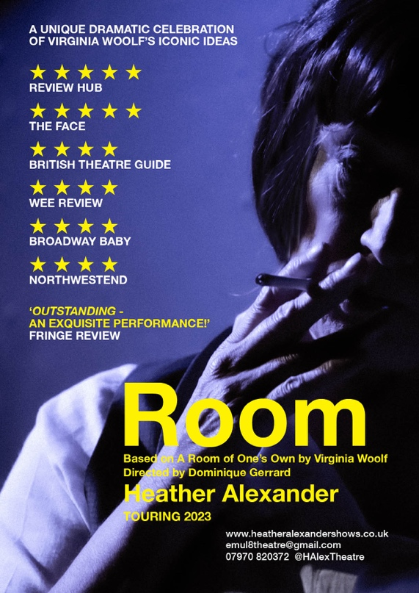

**Other Shows By Emul8 Theatre:**

**HAVISHAM**

**Available to book NOW!** http://www.heatheralexandershows.co.uk/havisham



**Other Shows by Emul8 Theatre**

Further details of these shows are available on request

